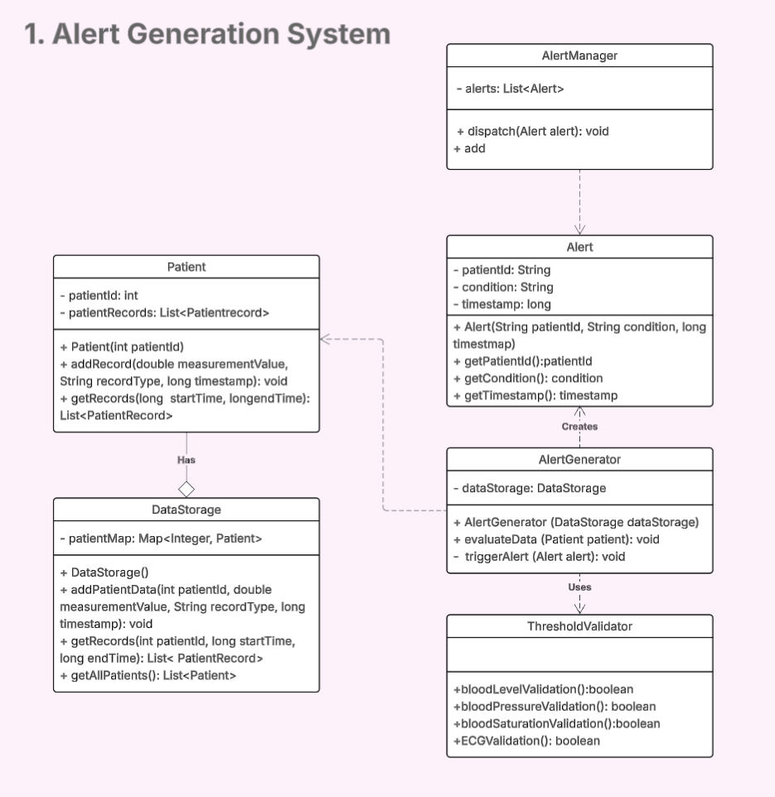

Alert Generation System diagram represents a real-time alert generation system for monitoring patient vitals, using personalized thresholds to trigger alerts when abnormal conditions are detected. Main design components are:

**TresholdValidator:** contains validation methods for different alert rules (e.g. “threshold: blood pressure > 100”) and returns a boolean value indicating whether a given condition is met or not.

**AlertGenerator**: evaluates patient data against thresholds from TresholdValidator using the DataStorage component to retrieve records. When thresholds are exceeded, it creates Alert objects containing patient ID, condition, and timestamp.

**AlertManager:** receives and dispatches alerts, ensuring that they are routed to the medical personnel. This decouples the alert handling logic from the core evaluation logic, what improves flexibility of the system.

**DataStorage:** maintains a map of Patient objects.

**Patient**: contains a list of patientRecords, representing time-stamped measurements.